REQUIREMENT ANALYSIS

Data Flow Diagram & User Stories

|  |  |
| --- | --- |
| Date | JUNE 2025 |
| Team ID | LTVIP2025TMID50867 |
| Project Name | ToyCraft tales: tableau's vision into toy manufacturer data |
| Maximum Marks | 4 Marks |

**Data Flow Diagrams:**

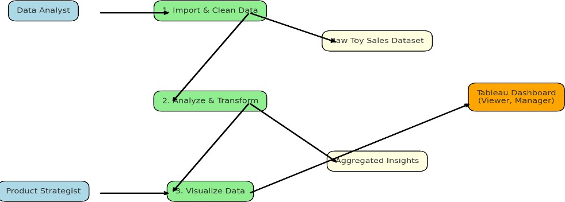

**User Stories**

|  |  |  |  |  |  |  |
| --- | --- | --- | --- | --- | --- | --- |
| **User Type** | **Functional Requirement (Epic)** | **User Story Number** | **User Story / Task** | **Acceptance criteria** | **Priority** | **Release** |
| Data Analyst | Data Upload | USN-1 | As a data analyst, I want to import and clean toy sales data for analysis | Data is cleaned and imported into Tableau correctly | High | Sprint-1 |
| Data Analyst | Data Transformation | USN-2 | As an analyst, I want to aggregate data by  category, region, and year | Aggregated dataset is ready for chart building | High | Sprint-1 |
| Product Strategist | Trend  visualizations | USN-3 | As a strategist, I want to see annual shipment and growth trends | Trendline appears with historical context | High | Sprint-1 |
| Marketing manager | Consumer Behaviour Insights | USN-4 | As a marketer, I want to filter toy preferences by region and demographics | Filtered visuals update dynamically | Medium | Sprint-2 |
| Product Manager | Category comparision | USN-5 | As a product manager, I want to compare toy | Bar/line charts for categories are generated | Medium | Sprint-2 |

|  |  |  |  |  |  |  |
| --- | --- | --- | --- | --- | --- | --- |
| **User Type** | **Functional Requirement (Epic)** | **User Story Number** | **User Story / Task** | **Acceptance criteria** | **Priority** | **Release** |
|  |  |  | category performance over years |  |  |  |
| Viewer | Dashboard experience | USN-6 | As a user, I want a full dashboard where I can explore all insights using filters | Dashboard loads with all visual components, slicers, and filters | High | Sprint-3 |